**MODULE – 6 ASSIGNMENT**

**Regular Expression**

1)Write a Python program to check that a string contains only a certain set of characters (in this case a-z, A-Z and 0-9)

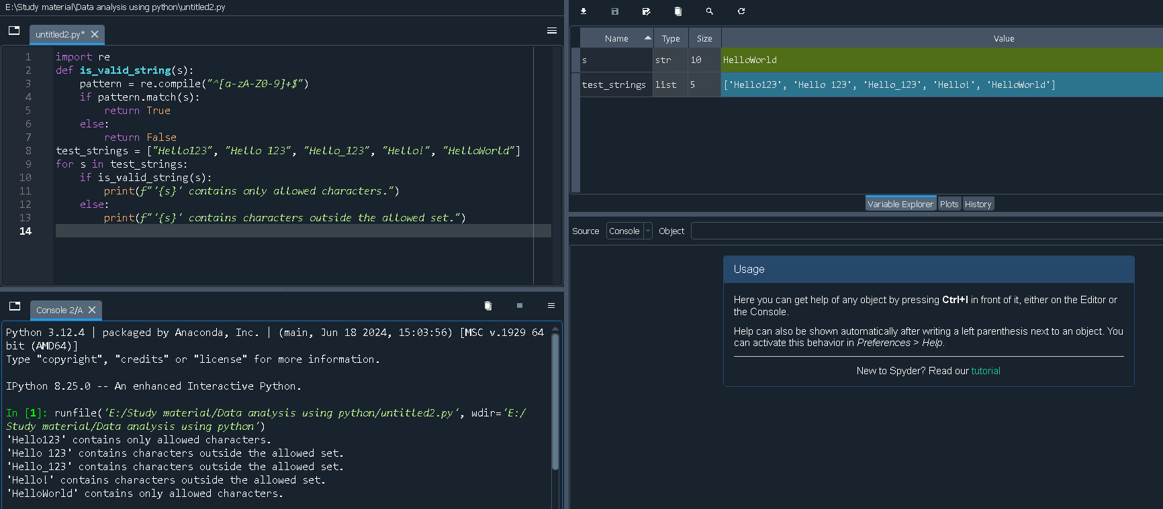

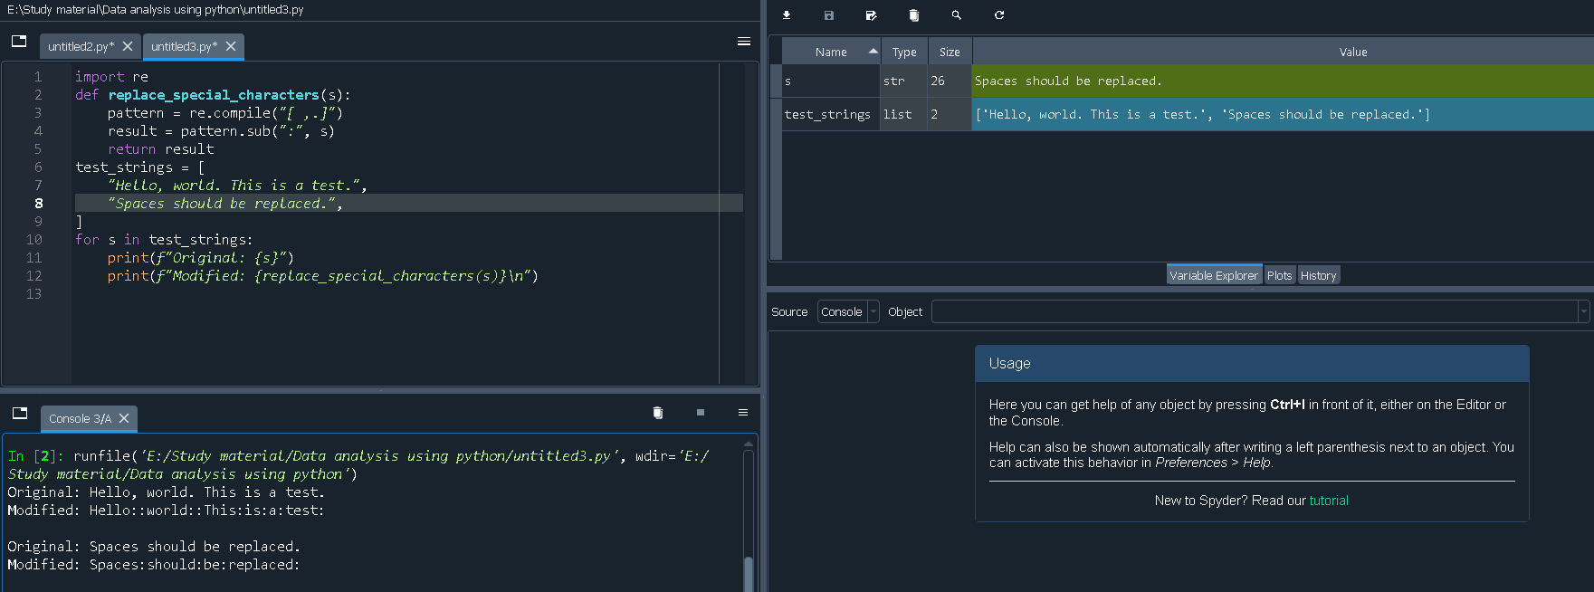2) Write a Python program to replace all occurrences of space, comma, or dot with a colon.